
QUALITY ALERT

Customer: AVANTI Date: May 2, 2023
Die: 15911 Colour: ALL
Type of Complaint: Customer COMPLAINTED

Q.A # Q.I.R # CUSTOMER NCR #

Description: Customer COMPLAINTED the screw hole was TOO BIG causing the reinforcement is TIGHT.
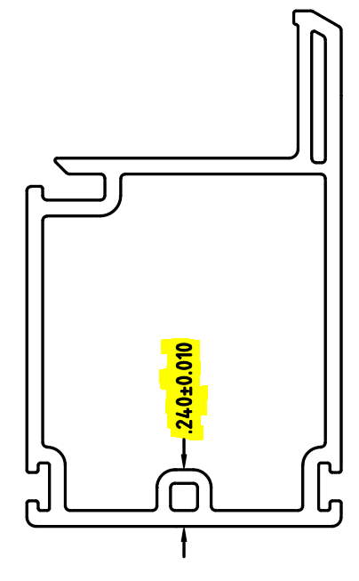
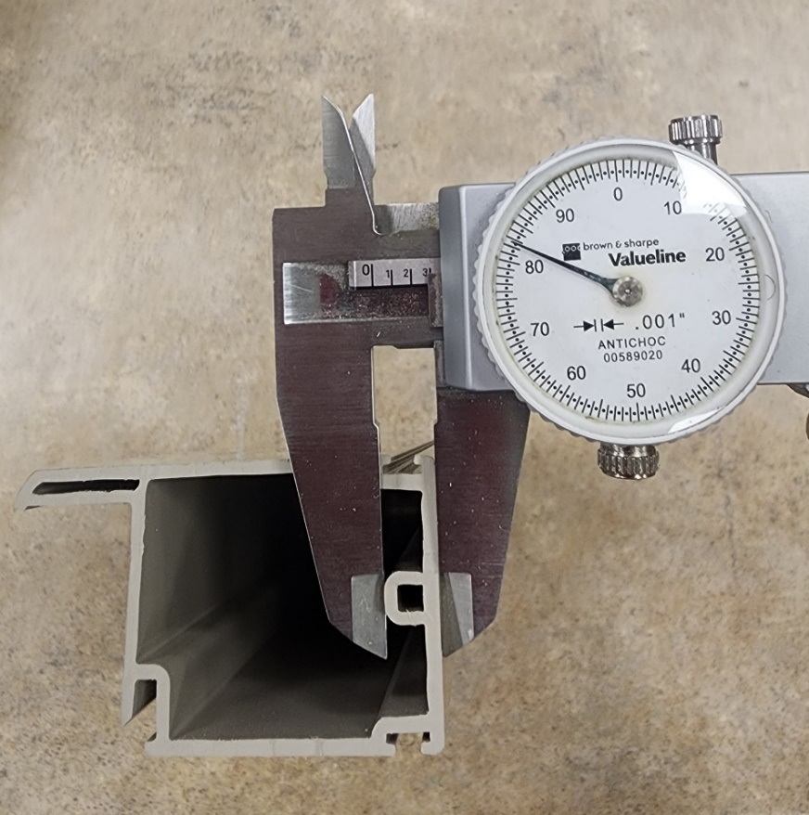

MAKE SURE THE DIMENSION MAXIMUM 0.250”

BY SIGNING BELOW, YOU ACKNOWLEDGE THE PROBLEM ABOVE AND AGREE TO MONITOR THIS ISSUE IN FUTURE PRODUCTION RUNS.
DAY SHIFT |  | AFTERNOON SHIFT |  | NIGHT SHIFT
NAME | SIGNATURE | NAME | SIGNATURE | NAME | SIGNATURE

